CURRICULUM VITAE  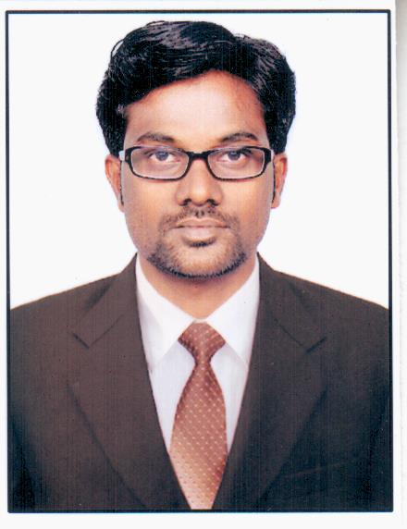  SURESH VEERASWAMY  Email: suresh_4u@rocketmail.com  sureshvkar@gmail.com  Mob: +91 8095148743  Personal Details:  Gender  Male  Date of Birth  20/7/1985  Nationality  Indian  Marital Status  Married  Languages Known  English, Hindi, Tulu, Kannada.Tamil  Passport Details  No: L9674442  25/06/2014 to 24/06/2024 |   CAREER OBJECTIVE  - To work in an environment that challenge me to continue learning and at the same to be able to help and learn as much as I can from my peers. To create a workspace that is in continual growth with opportunities for advancements  WORKING EXPERIENCE  - As a Graphic Designer for MANIPAL DIGITAL SYSTEM PRIVATE LIMITED, The Manipal Group, Manipal Udupi, for a period of 3.5 years (http://www.manipalsystems.com)  - As a Graphic Designer for Pinnacle media solution Manipal, India , for a period of 1.3 years  .(http://www.pinnaclemedia.in)  - Now working As a Multimedia designer for Omnion Premedia Pvt. Ltd for a period of 15 month  (http://www.omnion.biz)  1.JOB RESPONSIBILITIES IN IT DEPARTMENT  A+ and N+ Certification :  Installation,Configuration,TroubleShooting,Upgradation,  Trouble shooting of M/B, HDD, printer, monitor,SMPS,  Modem,internet, Multimedia,LocalAreaNetwork, TCP/IP  Cabling installation and configuration.  2.JOB RESPONSIBILITIES IMAGING DEPARTMENT  - Photoshop : Color correction , soft masking , High hand  Retouching, Image cutouts , Image sizing , image  Conversation , creating shadow , reflextion, etc.  - Indesign : Book work, Layout Design, fornt page, text Alignment , page setting  - Illustrator : Vector Designing , Creativity Designing Creating Bar code.  - Providing relevant support system to the middle management.  Photoshop export…….  TECHNICAL QUALIFICATION  - Graphics & Illustration Suite from MICE COMPUTER EDUCATION UDUPI.  - Fundamentals of Computer, Creating Illustration, Photoshop, Corel Draw. InDesign  ACADEMIC QUALIFICATIONS  - P.U.C. from Govt Pre-University College, Udupi. In the year 2008.  - S.S.L.C. from Nittur High School, Udupi, In the year 2006
COMPUTER PROFICIENCY
- Tools and Utilities : Microsoft Office 2000, 2007.
- Operating Systems : Mac, Windows 7, Microsoft Windows 2000, XP.

INTERESTS
- Playing Cricket, Swimming, Browsing Internet, Traveling.

PERSONAL ATTRIBUTES
- Hard work & Responsible Natured.
- Dedicated to continues developments.
- High level of ambition and motivation to work in a result oriented environment.
- Having very good convincing capacity.
- Exceptional customer service skills.
- Strong interpersonal & written communication skills.
- Good communication skill

PERMANENT ADDRESS
Do No-1/81, Janatha Colony Karamaballi, Kunjibettu Post
Udupi, Karnataka, India- 576 -101.

DECLARATION
I here by declare that all the information furnished in this is true to the best of my knowledge.

SURESH VEERASWAMY Date :

